When integrating Engageli with your Learning Management System (LMS), it can be helpful to include information in the course shell on how to use Engageli. Below are two proposed content sections, one for learners and one for instructors, that can be copied directly into a module or adjusted based on your course structure.

**FOR LEARNERS** [This could also be sent in an email.]

**Introducing Engageli**

Exciting news! This semester we will be using a new learning technology called Engageli. Engageli was purpose-built to foster active, collaborative learning, and deepen peer-to-peer connections.

Some of the classroom features include:

* Virtual tables: You will be “seated” at a virtual table with a small group of classmates.
* Chat: Send messages to the full class, as well as tablemater and individuals.
* Q&A: Ask questions through the threaded Q&A feature.
* Raise hand: Virtually raise your hand during class discussions to address the class.
* Notes: Take notes, including screenshots and annotations, which you can download at the end of class.

Here are some resources to help you learn more about Engageli and set up your device:

* [Quick start video](https://support.engageli.com/hc/en-us/articles/4411910147483-Learner-Quick-Start-Video-)
* [Logging in to class](https://support.engageli.com/hc/en-us/articles/4411910162331-Join-Your-Class)
* [Classroom overview](https://support.engageli.com/hc/en-us/articles/10516159689755-Interactive-Guide-for-Learners)

Engageli has been integrated with our Learning Management System, so you should plan to join all classes directly through the course modules.

If you have any login or connection issues, please contact Engageli's Live Support by [email or chat](https://support.engageli.com/hc/en-us). You can also select **Contact support for help** within the Engageli classroom to be directed to the Engageli Help Center.

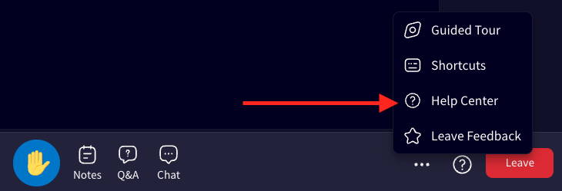

**Classroom Link**

**Office hours:** The link you use to join the live class is the same link you will use to access the classroom for office hours.

**Recordings:** If you miss class, recordings will be available by clicking the classroom link. Instead of the live class, you will select the [Playback Room](https://support.engageli.com/hc/en-us/articles/10478505198619-How-to-Use-Playback-Rooms-Learner-3-0-).

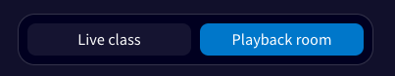

Playback Rooms are asynchronous environments that house all the live session recordings where you can, independently or in a group of up to 10 peers, access and engage with course content. Playback Rooms are open 24/7 and learners can use them for independent and group work without instructors or TAs.

You can gather to review class recordings, access self-paced materials, collaborate on whiteboards, participate in polls, ask and answer questions in the Q&A, take notes, and chat, talk, and learn with other classmates.

**FOR INSTRUCTORS** [This folder should only be viewable to instructors. Or, it can be included in an individual onboarding course for all instructors.]

**Instructor Classroom Link**

**Instructor Portal Link**

[**Classroom Overview**](https://support.engageli.com/hc/en-us/articles/10569039857051-Instructor-Interactive-Guide-Browser-)

[**Getting Started on Engageli**](https://www.engageli.com/start)

[**Preparing for Your First Class**](https://support.engageli.com/hc/en-us/articles/19473311676571-Prepare-Your-Learners)

[**Admin Portal Guide**](https://support.engageli.com/hc/en-us/articles/19198559462043)

There are two suggested paths if you would like to get feedback on the Engageli learner experience, there are two suggested paths.

* You can provide an online survey at the end of the course.
* You can conduct a survey at the end of a live class using Engageli poll questions so that learners who missed the class can answer the questions when they watch the recording in a Playback Room.

For both options, Engageli has sample questions that you can use.

**Helpful Reminders**

* Remember to check the course syllabus to ensure there are no mentions of other tools (e.g., Zoom, WebEx, or Teams).
* Ask learners to join their first class 15 minutes early, or try to log in to Engageli before the first class to make sure they can join the classroom without any issues.