Here are a few Engageli reminders for your first day of class.

**Before the start of class**

* Start your class at least ten minutes early
* Name your tables, if needed
* Turn discussion mode onif you would like the class to hear other each
* Post question(s) in Q and A - it is available in your Engageli class throughout the semester for both live and recorded classes

**At the start of class**

* Decide if you want to turn discussion mode off so that only tablemates can talk to each other
* Introduce the Engageli representative for student support during the class.
* Explain how tables work - students can collaborate with tablemates without disrupting the class, students can share their screen with tablemates, students can chat to tablemates
* Record your lecture
* Housekeeping notes
  + Remind your students to take notes within the platform
  + Remind students to raise hands so they are at the front of the class
  + Ask students to turn cameras on if they feel comfortable
  + Ask students to use thumb up/thumbs down when you ask questions - “Are you ready for the next class activity?” etc

**Polls**

* Use [polls](https://support.engageli.com/hc/en-us/articles/4411747696795-Create-a-Poll-or-Quiz) for icebreakers, checks for understanding
* Have one poll closer to the end of the lecture so that attendance can be tracked for students who watched the recording and answered the poll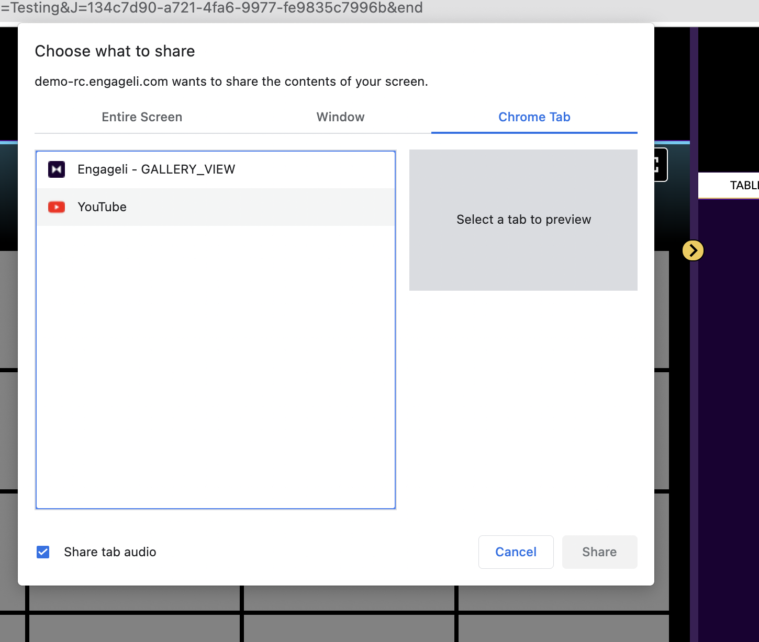

**Music before class**

To play music before the session, screenshare the browser tab select "share tab audio." This will ensure that the audio is playing to all learners and you can mute your microphone.

This will only work if you are sharing a tab in the screen share.

**Group activity**

* Pause the recording when there is table-based activity happening, so that there is no dead air time for students watching the lecture recording
* Set a timer for activities
* Unmute gallery when the activity is complete (If you muted gallery during group activity)
* Visit tables to check each table is making progress
* Randomize seating for different group activities so that students can get to meet more peers

**Before the end of class**

* Remind students to download their notes
* Download the chat for your records